**Software Design Lab**

**[Project Name]**

**Projekt Documentation**

[TODO: Select your own background image!!!]

Team: Ultras

Name Portenkirchner, Zuzan MatNr.

Release: Tag. Monat Jahr 19. 11 2018

**Intro** **3**

Current situation (Current situation, planned improvements) 3

Project Goals(Planned result, Goal) 3

No Project Goals 3

**Use Case Diagrams** **3**

**Use Case Descriptions & Activity Diagrams** **3**

**Domain Model (CDM) and Descriptions** **3**

**Selected Technology** **3**

**System Architecture, Component Diagrams and Descriptions** **3**

**Class and Sequence Diagrams** **3**

**Deployment Diagrams** **3**

**Implemented System** **3**

**Conclusion (What was reached / not reached. Next steps)** **3**

# Intro

## Current situation (Current situation, planned improvements)

## Project Goals(Planned result, Goal)

## No Project Goals

# Use Case Diagrams

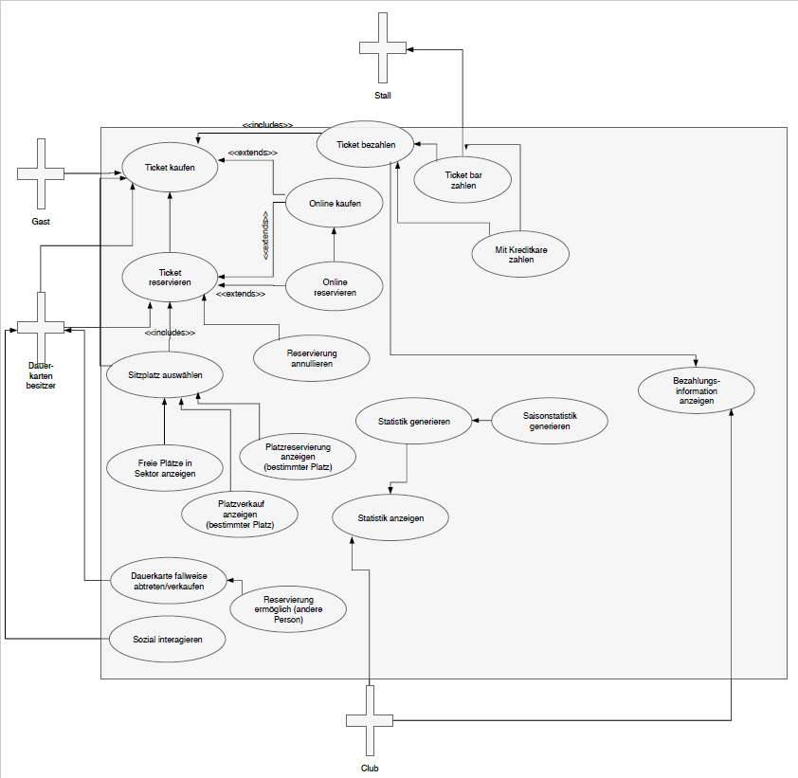

# 

# Use Case Descriptions & Activity Diagrams

|  |  |  |  |
| --- | --- | --- | --- |
| Use Case ID: | 1 | | |
| Use Case Name: | Buy Ticket online | | |
| Created By: | Ultras | Last Updated By: |  |
| Date Created: | 02.11 | Date Last Updated: |  |

|  |  |
| --- | --- |
| Actors: | customer |
| Description: | Customer can buy a ticket via web |
| Trigger: | Log in |
| Pre-Conditions: | 1. Customer want to visit a game, Customer needs a user account |
| Post-Conditions: | 1. Ticket is bought, confirmation E-mail has been sent |
| Normal Flow: | 1. 🡪activity diagram |
| Alternative Flows: | 🡪activity diagram |
| Exceptions: | Creditcard invalid, stadion sold out |
| Includes: | Log in, choose sector/seat/category |
| Priority: | O(one dimension, absolute must have) |
| Frequency of Use: | 10000/week |
| Business Rules: | Max. 4 tickets/person |
| Special Requirements: | / |
| Assumptions: | / |
| Notes and Issues: | / |
|  |  |

|  |  |  |  |
| --- | --- | --- | --- |
| Use Case ID: | 2 | | |
| Use Case Name: | Reserve Ticket online | | |
| Created By: | Ultras | Last Updated By: |  |
| Date Created: | 02.11 | Date Last Updated: |  |

|  |  |  |  |  |
| --- | --- | --- | --- | --- |
| Actors: | | customer | | |
| Description: | | Customer can reserve a ticket via web | | |
| Trigger: | | Log in | | |
| Pre-Conditions: | | 1. Customer want to visit a game ,Customer needs a user account and a season card | | |
| Post-Conditions: | | 1. Ticket is reserved, confirmation E-mail has been sent | | |
| Normal Flow: | | 1. 🡪activity diagram | | |
| Alternative Flows: | | 🡪activity diagram | | |
| Exceptions: | | stadion sold out | | |
| Includes: | | Log in, choose sector/seat/category | | |
| Priority: | | O(one dimension, absolute must have) | | |
| Frequency of Use: | | 1000/week | | |
| Business Rules: | | Max. 4 tickets/person, owner of season Ticket, Customer must be owner of a season card | | |
| Special Requirements: | | / | | |
| Assumptions: | | / | | |
| Notes and Issues: | | / | | |
| Use Case ID: | 2 | | | |
| Use Case Name: | Reserve Ticket online | | | |
| Created By: | Ultras | | Last Updated By: |  |
| Date Created: | 02.11 | | Date Last Updated: |  |

|  |  |  |  |
| --- | --- | --- | --- |
| Use Case ID: | 3 | | |
| Use Case Name: | Share season card | | |
| Created By: | Ultras | Last Updated By: |  |
| Date Created: | 02.11 | Date Last Updated: |  |

|  |  |
| --- | --- |
| Actors: | Owner of season card |
| Description: | Customers can share their season cards when they don’t need it |
| Trigger: | Log in |
| Pre-Conditions: | 1 Customer needs a user account and a season card |
| Post-Conditions: | 1. Season Ticket is online, confirmation E-mail has been sent |
| Normal Flow: | 1. 🡪activity diagram |
| Alternative Flows: | 🡪activity diagram |
| Exceptions: | / |
| Includes: | Log in, choose game |
| Priority: | O(one dimension, absolute must have) |
| Frequency of Use: | 1000/week |
| Business Rules: | Max. 4 tickets/person, owner of season Ticket |
| Special Requirements: | / |
| Assumptions: | / |
| Notes and Issues: | / |

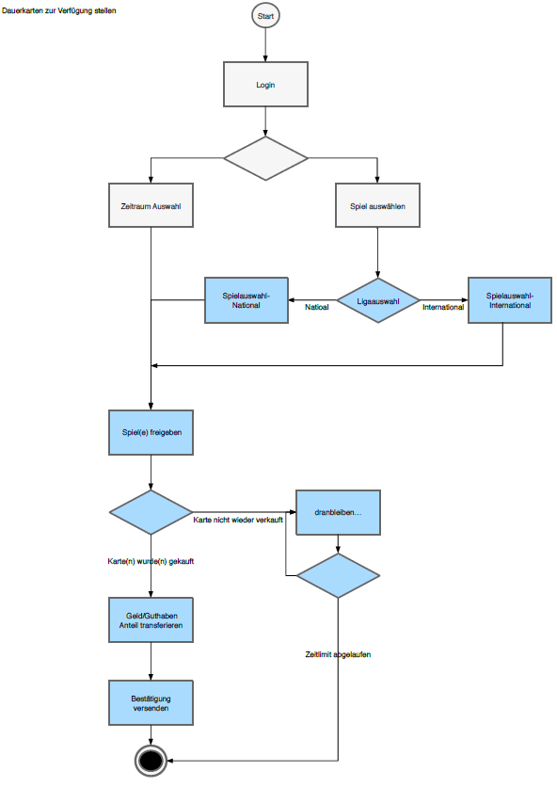 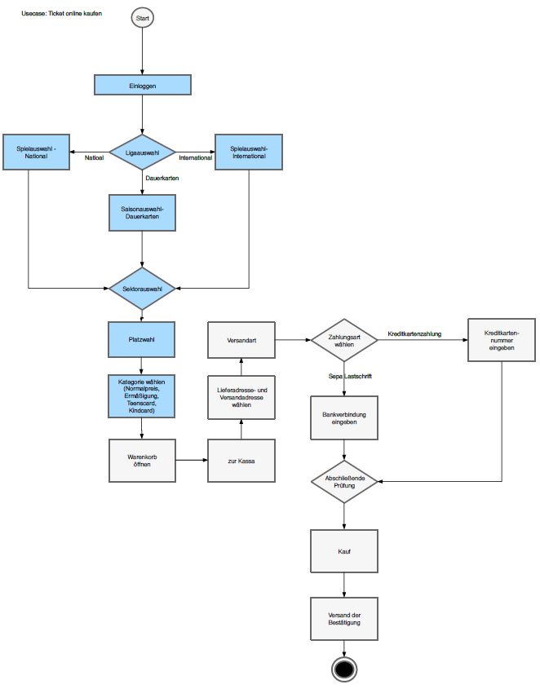

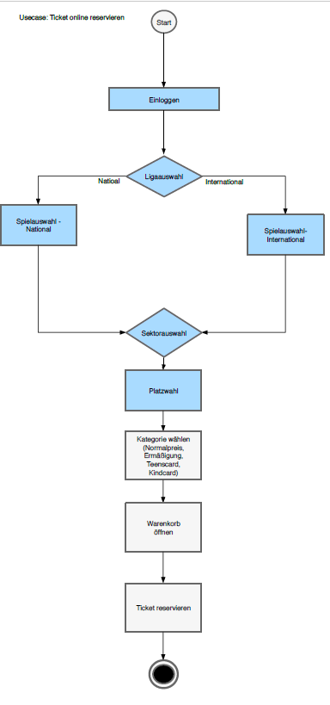

# Domain Model (CDM) and Descriptions

# Selected Technology

Java Enterprise Edition

# System Architecture, Component Diagrams and Descriptions

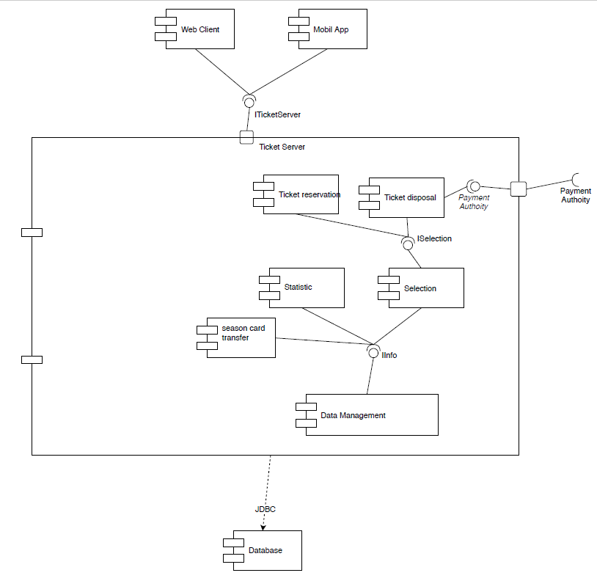

# Class and Sequence Diagrams

# Deployment Diagrams

# Implemented System

# Conclusion (What was reached / not reached. Next steps)